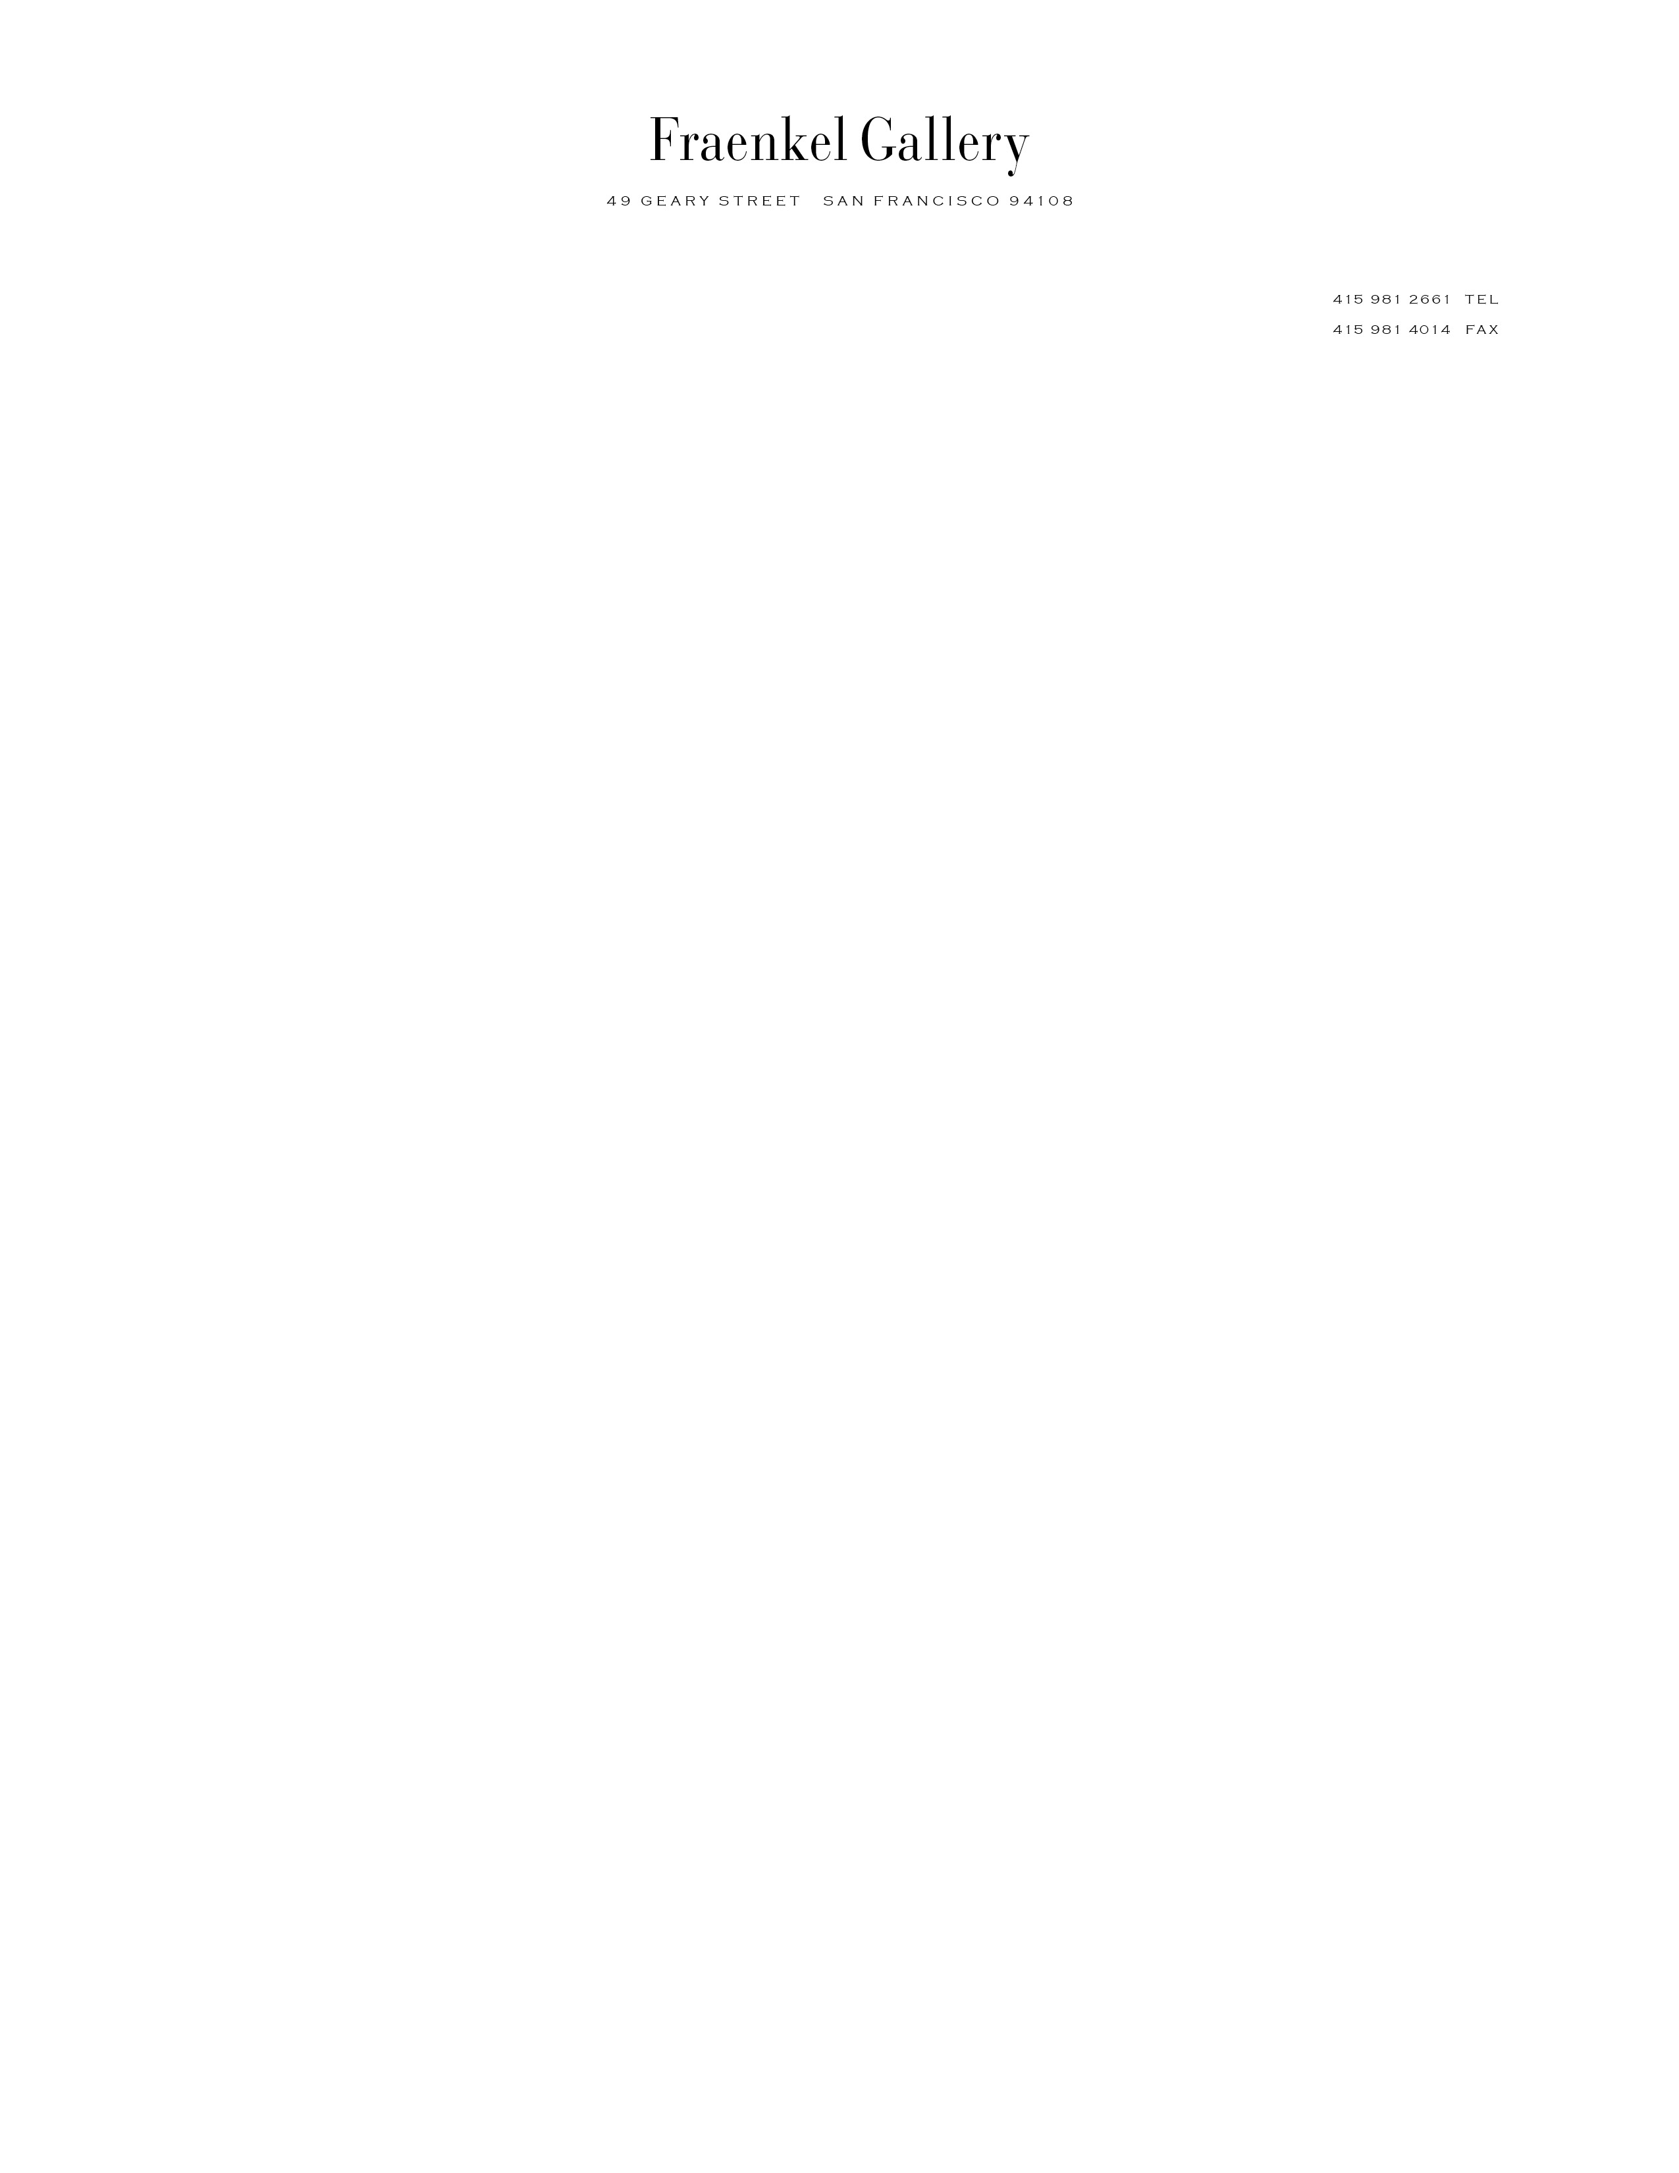

Dear Sir or Madam,
Lissa McClure at Marian Goodman suggested that I write you directly for permission to reproduce one Richter work in a forthcoming exhibition catalogue of Fraenkel Gallery.
We are borrowing this work from a private collection in San Francisco, for an exhibition to be titled "The Unphotographable." The exhibition addresses the subject of "that which cannot be photographed."
The work is titled "September," 2009 (below).
This would be reproduced full page, and of course would not be cropped or otherwise altered.
The exhibition and catalogue also includes work by Diane Arbus, Sophie Calle, Man Ray, Christian Marclay, Alfred Stieglitz, Hiroshi Sugimoto, and Wolfgang Tillmans, among others.
We would very much like to secure your permission to reproduce this image in the catalogue, and would include any credit or copyright information you request. Two copies of the catalogue will be sent to you upon completion in December.
Please let me know if you have any questions. I look forward to hearing from you soon.
Sincerely,
Jeffrey Fraenkel
President
Fraenkel Gallery

